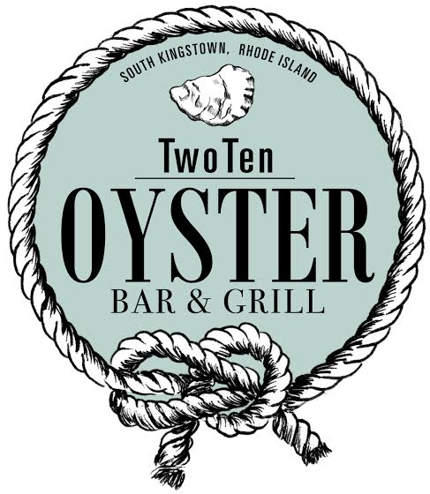
Restaurant Week Dinner Menu
October 31st – November 9th
$24.14
Choice of Soup or Salad
Organic House Salad
Organic grape tomatoes, cucumbers and julienne carrots with choice of dressing
House Caesar Salad
Organic romaine hearts tossed with grana padana cheese and croutons with Caesar dressing
Soup du Jour
New England Clam Chowder
Rhode Island Clam Chowder

Choice of Appetizer
(2) Oyster Rockefeller
Personal RI Calamari
Stuffed Quahog

Choice of Entrée
Baked Atlantic Cod
Atlantic cod baked with lemon dill butter and topped with crispy breadcrumbs served with red bliss potatoes and chefs vegetables.
Pairs best with Sonoma Coutrer Chardonnay.

Linguini and White Clam Sauce
Steamed Littlenecks, fresh chopped clams, in a garlic and white wine butter sauce garnished with garlic toast points.
Pairs best with Barone Fini Pinot Grigio.

Chicken Penne a la Vodka
House made pink vodka sauce finished with fresh grana padana cheese.
Pairs best with Michael David Sauvignon Blanc.

Grilled Faroe Island Salmon
Roasted fennel & black olive tapenade, mesclun, fig balsamic with red bliss potatoes.
Pairs best with 7 Deadly Sins Red Zinfandel.

Southwest Spiced Yellowfin Tuna
Arugula, shaved onions, oven roasted native tomatoes, tequila roasted tomato vinaigrette, quesso fresco, fried sundried tortilla chips with couscous.
Pairs best with La Crema Pinot Noir.

Steak Au Poivre
Certified Angus Sirloin, peppercorn demi, horseradish mash, topped fried onion straws.
Pairs best with Freakshow Cabernet.

